FAITH REFORMED CHURCH
Rev. Zach Tarter, Pastor Jon Damkot, Youth Director
243 S 4th St, Cedar Grove, WI 53013 920.668.6725
www.faithreformedchurch.org
If you wish to reach Pastor Zach, you may dial the church office or reach him by cell phone at 920-212-5489. His office hours are Monday-Friday 8:30-5:30p.m.
Elder on Call: If you are unable to reach Pastor Zach you may contact the Elder on Call. Elder on call for September is John Morgan (262-227-6650).
Officer Nominations: September begins the Elder/Deacon nomination process which starts with members participating in a time of self-examination. A letter explaining the nomination process has been placed in your mailbox. Please read it carefully and prayerfully consider serving as an officer. If you must excuse yourself from being nominated for either or both of the offices of Elder or Deacon, you must contact Pastor Zach or one of the Elders with your name and reason for the request by September 27th. The nomination list and ballots will be distributed the first week in October
Cedar Grove Area Food Pantry update – We served 27 people at the Food Pantry in September. There is a barrel outside Faith Reformed by the west doors for donations; right now we are low on peanut butter, soup, canned fruit & cereal. (Please check the expiration dates on the food you donate.) If you’d like to volunteer at the Food Pantry, please contact Faith’s office at (920) 668-6725. Thank you for your generous giving!
October Newsletter will come out on September 27th. I will need your articles by September 20th. Debbie
Love Inc needs for September: Sew Caring - New standard-size Bath Towels & Hook and Loop (Velcro). You may place your donations in the gray tub in the great room. For questions on your donations, please contact your Love, Inc Representative, Mike Heinen (920-912-1256).
Prayer Gathering: Prayer Meeting will be held at 7:00pm on Wednesdays in September on Pastor Zach’s patio.
Save the Date! The annual 24 Hour Prayer event is scheduled for 8AM Friday, Sept. 18 to 8AM Saturday, Sept. 19. Sign up by the mailboxes, or through the sign-up Genius link found on the Special Events page of the church website.

FALL SCHEDULE FOR YOUTH: No Children’s Church, Nursery or Sunday School in September - they will start Oct. 4th. Adventure Island outdoors Until Sept. 30th. Connect is also meeting in Independence Park from 6:00-7:30 p.m. All these things are subject to change at any time!
Faith Fall Festival & Welcome to the Tarter family: A date has been set to welcome Pastor Zach and his family & have a Fall Festival on Saturday, October 3rd in Memorial Park from 3:00-6:30 p.m. See the insert in your bulletin for more information.
It is our pleasure to invite you to the Pine Haven Annual Meeting of the Corporation on September 21, 2020 at 6:00pm. In light of the COVID 19 pandemic, we will not be hosting a dinner. Our meeting will be held in the Family Life Center at First Reformed Church in Sheboygan Falls. COVID safety protocol requirements will include wearing masks and social distancing. Further information of our meeting can be found here www.pinehaven.org/events. We will be voting on our Amended and Restated Articles of Incorporation of Pine Haven Christian Home, Incorporated.
Ladies! It’s that time of year to be (re)gathering a group of women to meet (virtually or socially distanced) for Bible Study and spiritual growth/fellowship. The Women’s Ministry Team has compiled a list of resources to guide your decision making process on what to do. See the resources tab on the church website for the list, including links to the materials. If you need assistance forming a group to meet with please reach out to Kim or Sherri.
The congregation extends sympathy to Al & Mary Holle on the death of her brother, Don Buyze living in Michigan. He is also uncle to Phil Holle & Mrs. Kim Hoitink and the cousin of Herb Dirkse.
Love INC Brat Fry Drive thru or Walk Up/Bake sale will be held at Mentink’s Market on Saturday, October 3 from 10:00 a.m. – 3:00 p.m. Please stop for a brat or burger and take home some delicious baked goods.
“Adult Sunday School will begin again on October 4 as B.J. Hilbelink will be taking us through a 6-week overview of the Old Testament. Many times the Old Testament feels like an ancient mystery book that we cannot understand! But B.J. will help us to see how God’s Word is a unified story leading to Christ, and how we can better understand the details of God’s Word when we see the big picture.”

CONGREGATIONAL PRAYERS
Praises and Thanksgivings
God’s gift of salvation and the cross
God’s faithfulness to Faith Reformed
Petitions
A ministry heart as believers
Commitment to be people of prayer
Commitment to studying Scripture
To be guided by Scripture, not culture
Courage to stand firm for the gospel
Our hearts to be focused on Christ
Our church Officers
Jon Damkot – Youth Director
Disciplemaking at Faith Reformed
Our members to grow in Christ
Our students attending school
School leaders and teachers
Those serving in the military
The churches in Cedar Grove
Hurricane/Fire victims
Those with addictions/in jail or prison
Persecuted Christians
Health
John Newton has skin cancer on his face and will have surgery the end of the month-Keep John in your prayers!
Ron Meinen – on going treatment
Don Schruers – Will no longer have Carotid Artery Surgery – Appointment tomorrow with Dr. Pond
Kim Hoitink – continuing health concerns after his tumor removal
Those with a cold, flu, or the corona virus
Grieving
Don Buyze – brother of Mary & Al Holle, uncle of Phil Holle & (Mrs.) Kim Hoitink & cousin of Herb Dirkse
Mission & Outreach
Mike & Ann Prom (WILD)
Witness of Christ’s love to local families
For our unchurched neighbors
SHUT-INS
Cedar Grove Gardens –
Warren Heinen Building 2 Room #1
Phyllis Heinen Building 2 – Room #6
Pine Haven Covenant Home-Frannie Meinen/Room #318
At Home: Elda Veldboom

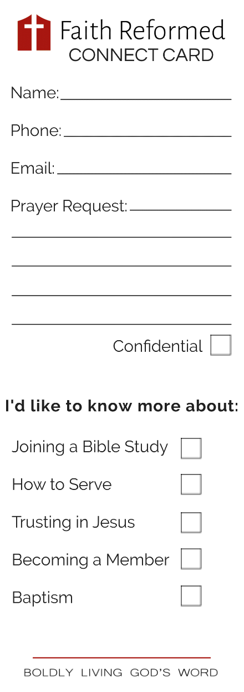

Youth News

CORE Opening Night (Grades 6-12) - Tonight, September 13th at Faith Reformed Church. Come reunite with your small group outdoors from 6:00-7:00PM.
CONNECT (Grades 6-12) - Wednesday, September 16th - Come Connect with each other & God at Independence Park from 6:00-7:00PM.
Adventure Island Opening Night! (Grades K-5) - Wednesday, September 16th outdoors at Faith Reformed Church from 6:00-7:00PM. Registration & games begin at 5:45.
Sunday school teacher needed - We still have one spot open for teaching 4th grade Sunday school. Please let Jon know if you have interest.
Sunday School Teacher Orientation - Sunday school teachers will meet in the basement (in the addition) next Sunday, September 20th after the service.
Sunday School Students (Oct. 4th) – remember to bring your offering to class so we can continue to sponsor 2 children from Compassion International.

September Birthdays: Please remember these people with cards of Birthday blessings
Joan Meylink will turn 90 on September 6
Ron Meinen will turn 80 on September 9
Marge Dirkse will turn 86 on September 26

Deeply Loving God
Authentically Loving Others
Boldly Living God’s Word

September 13, 2020

APPROACH TO GOD
Prelude Jamison Velzke
Call to Worship Dan Weiss
*Praise Songs
*Greeting One Another
Prayer of Praise and Confession
Assurance of Forgiveness
THE WORD OF GOD
Children’s Message Jon Damkot
Scripture Lesson 1 Peter 5:1-5; 1 Timothy 3:1-7 Pages # 1206/1178
Sermon “Faithful Shepherds” Pastor Zach Tarter
OUR RESPONSE TO GOD
* Hymn –# 365 Savior, Like a Shepherd Lead Us
*Affirmation of Faith – Heidelberg Question 31 & 32
Offertory Prayer Bob DeRuyter
Special Music “Redeemed”
Congregation Sharing
Congregational Prayer
*Benediction
*Doxology
*Postlude Jan Jerabek _______________________________________________________________
We welcome all who have come to worship on this glorious Sunday. May we all be open to the benefits of God’s grace. Let us worship him in Spirit and in truth.
*Congregation standing if able
*Masks: As we are currently under a mask mandate in Wisconsin, we do expect those attending to wear a mask while inside the church building (unless you are exempt due to a medical condition). There are disposable masks available in the narthex and cloth masks in Pastor Zach’s office!

