Sunday School 11/22/20
The Synoptic Gospels
- OT Summary
OT Summary: The Old Testament is about God’s plan…to bless all peoples…by bringing them back into His presence…for His praise… through His Promised One…starting with His chosen people, Israel.
  - God’s Plan
    - Adam and Eve
    - Abraham
    - Israel
    - David
    - Sin and Exile
  - Prophetic Promises
    - King from David’s Family and Kingdom Restored (Isa. 7:14; Isa. 9; Isa. 11)
    - Forgiveness of Sins through Suffering Servant (Isa 53)
    - New Covenant (Jeremiah 31-33; Ezek 37)Forgiveness ; Holy Spirit; All nations blessed; New Creation; New Temple; Explosion of Praise
  - End of OT=Promises Unfulfilled
  - New Testament
NT Summary: We find the accomplishment of God’s plan…to bless all peoples…by bringing them back into His presence….for His praise….through His Promised One….in fulfillment of all His OT promises to Israel.
In the OT, the Law revealed God as the One who created everything, and redeemed His people out of slavery in Egypt to bring them into communion with Him and to live for His glory in the world.
In the NT, the Gospels reveal Christ as the One who brings new creation by redeeming His people out of slavery to sin to bring us into full communion with Him and to live for His glory in the world.
- Intro to the Gospels
  - Gospel=Good News
  - Definition: Good News of who Jesus is and what He has done to bring the promised Kingdom of God in fulfillment of God’s OT promises.

- Intro to the Synoptic Gospels
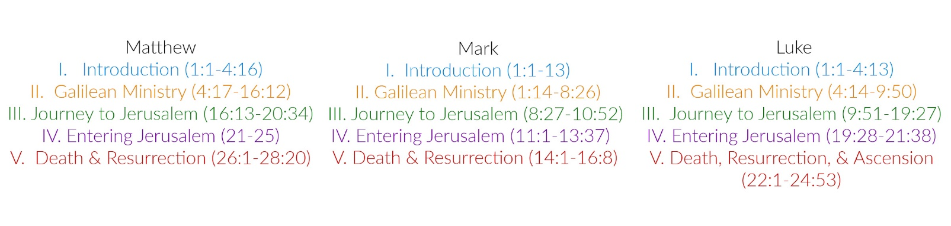
  - Similarities

  - Differences
    - Matthew
      - Unique Intro
      - Matthew also has a Unique Birth Narrative
      - Emphasizes OT Fulfillment in Christ
      - Jesus as the Lawgiver
    - Mark
      - Likely the first one written
      - By far the shortest Gospel
      - Unique Intro
      - Fast-Paced
      - Slows Down
    - Luke
      - Longest book in the NT [not only longest Gospel]
      - Also a Unique Introduction
      - He also gives more on John the Baptist’s birth as a parallel to Jesus
      - Luke Probably a Gentile!!
      - Emphasizes the poor more than any other Gospel writer…
      - Emphasizes the Redemptive Plan of God in the OT

- Five Themes in the Synoptic Gospels
  - Jesus Fulfills The Promises to David
    - Matthew 1:1: “The book of the genealogy of Jesus Christ, the son of David, the son of Abraham.”
    - Luke 1:32–33 same thing as angel speaks to Mary: “And the Lord God will give to him the throne of his father David, ³³ and he will reign over the house of Jacob forever, and of his kingdom there will be no end.”
  - Jesus Fulfills the Promise to Abraham
    - Matthew 1:1: “The book of the genealogy of Jesus Christ, the son of David, the son of Abraham.”
    - Matthew 28:18 “..make disciples of “all nations,…”
    - Luke 1:54–55: “He has helped his servant Israel, in remembrance of his mercy, ⁵⁵ as he spoke to our fathers, to Abraham and to his offspring forever.”
  - Jesus Brings the Kingdom to Earth as God
    - Matthew 3:1–3: ¹ In those days John the Baptist came preaching in the wilderness of Judea, ² “Repent, for the kingdom of heaven is at hand.” ³ For this is he who was spoken of by the prophet Isaiah when he said, “The voice of one crying in the wilderness: ‘Prepare the way of the Lord; make his paths straight.’ ”
    - Mark 1:15: “The time is fulfilled, and the kingdom of God is at hand; repent and believe in the gospel.”
  - Jesus Brings the Promised New Covenant in His own Blood
    - Luke 22:19–20: And he took bread, and when he had given thanks, he broke it and gave it to them, saying, “This is my body, which is given for you. Do this in remembrance of me.” ²⁰ And likewise the cup after they had eaten, saying, “This cup that is poured out for you is the new covenant in my blood.”
  - Jesus Gathers and Deploys a New Covenant People
    - Luke 24:44–49: “[Jesus] said to them, “Thus it is written, that the Christ should suffer and on the third day rise from the dead, ⁴⁷ and that repentance for the forgiveness of sins should be proclaimed in his name to all nations, beginning from Jerusalem.

